Waabanong Weekly Update
Delivered August 10, 2026
Week of August 3 to 7, 2026
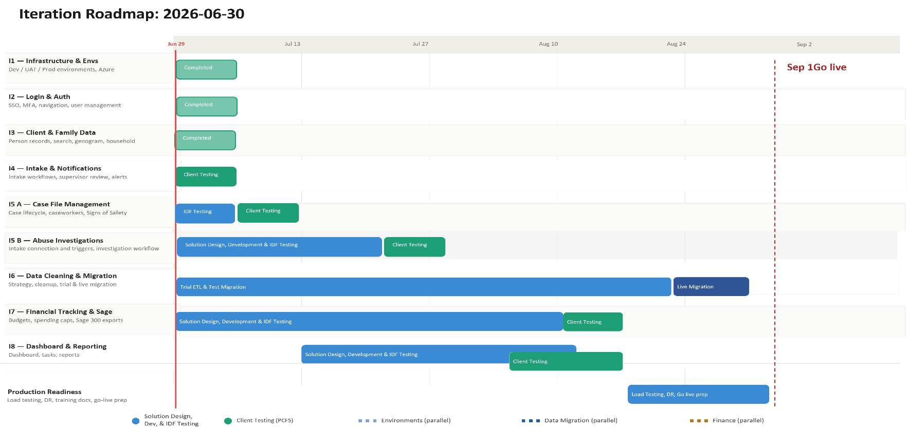

Iteration | Status | Current phase | Notes
I1 - System Infrastructure & Environments | Complete | Maintenance | Build housekeeping; production environment build underway
I2 - Login & Authorization | Complete | Maintenance | No changes this week
I3 - Client, Member & Family Data | Complete | Maintenance | No changes this week
I4 - Intake Management & Automated Notifications | Complete | Maintenance | No changes this week
I5 A - Case File Management & Signs of Safety | Complete | Maintenance | No changes this week
I5 B – Abuse Investigations | In Progress | Development | Referral form and offender-handling fixes continue
I6 - Data Migration | In Progress | Design | Contingency budget confirmed; production environment build underway
I7 - Financial Tracking & Exports for Sage | In Progress | Design | No activity this week
I8 - My Dashboard & Reporting | Not Started | — | No activity this week

Project Management & General
Weekly Progress
- Rob confirmed the FAMCare source data is rougher than anticipated and the project's contingency budget will be drawn on for migration cleanup — exact amount still being assessed
- Go-live timeline confirmed slipping again, for two reasons: slower-than-expected live-data access, and staggered UAT pushing back reporting/dashboard module design
- Ross reconfirmed his preference to prioritize migration accuracy over the original deadline
- Waabanong production environment build kicked off (Aug 4) with IDFusion and PCFS's IT provider, expected to complete within the week
- General navigation and log-entry modal usability improvements this week
I1 - System Infrastructure & Environments
Features
- Set up Development, Testing, and Production environments
Weekly Progress
- Stopped tracking machine-local dompdf font cache (build cleanup)
- Production environment build underway with Campfire/PCFS IT
I2 - Login & Authorization
Features
- Microsoft 365–based authentication
- User login
Weekly Progress
- No authentication changes this week.
I3 - Client, Member & Family Data
Features
- Centralized person records (children, adults, limited profiles)
  - Duplicate prevention
- Family and household structures
  - Multi-generation relationships
- Reciprocal relationship logic
- Global search across people and families
Weekly Progress
- No changes this week.
I4 - Intake Management & Automated Notifications
Features
- Structured intake workflows with mandatory fields
- Intake status tracking and lifecycle
- Supervisor review and approval processes
- Ability to resolve intake without opening a case
- Escalation from intake to case creation
- Printable intake records
- Automated notifications:
  - In-application alerts
  - Defined external channels (email/messaging)
Weekly Progress
- No changes this week.
I5 A - Case File Management & Signs of Safety
Features
- Case file creation and lifecycle management
- Assignment of caseworkers and supervisors
- Case reassignment with approval
- Signs of Safety–aligned workflows, including:
  - Placement
  - Structured assessments
  - Safety goals and planning
  - Ongoing review checkpoints
- Visibility into historical and related cases
- Case notes for visits, services, and interactions
- Communication tracking across intake and case contexts
  - Document management: Person, Intake & Case
Weekly Progress
- No changes this week.
I5 B – Abuse Investigations
Features
- Triggers and integration with Intake module
- Investigation workflow
- Investigation document management

Weekly Progress
- Added gender specification fields to referral forms
- Added victim-options retrieval for Report to Abuse forms; related modal functionality updated
- Genogram updated to exclude selected victims from offender options, with improved pagination accuracy
- Fixed Intake Report Form issue where the offender was not being added to Persons Involved
I6 - Data Cleaning and Migration
Features
- Develop a data migration strategy from FAMCare into Waabanong
- Support PCFS as they perform data cleanup
- Execute trial data migrations in a sandbox environment
- Perform live data migration
Weekly Progress
- Contingency budget confirmed needed for FAMCare migration cleanup — exact amount still being assessed
- Production environment build kicked off (Aug 4), which will allow IDFusion to begin working with a copy of the FAMCare database once complete
I7 - Financial Tracking & Exports for Sage
Features (Potential scope may include)
- Intake-level emergency supports
- Case-level budgets
- Spending caps and approvals
- Export files to import into Sage 300
Weekly Progress
- No activity this week.
I8 - My Dashboard & Reporting
Features (Potential scope may include)
- My Dashboard (simple, quick reference to key items)
- Tasks & alerts
- Reporting (if required and not covered in other iterations)
Weekly Progress
- No activity this week.

